**#1**

* **Web Browser: Login your gmail**
* **Android Studio, check to make sure that you already installed:**

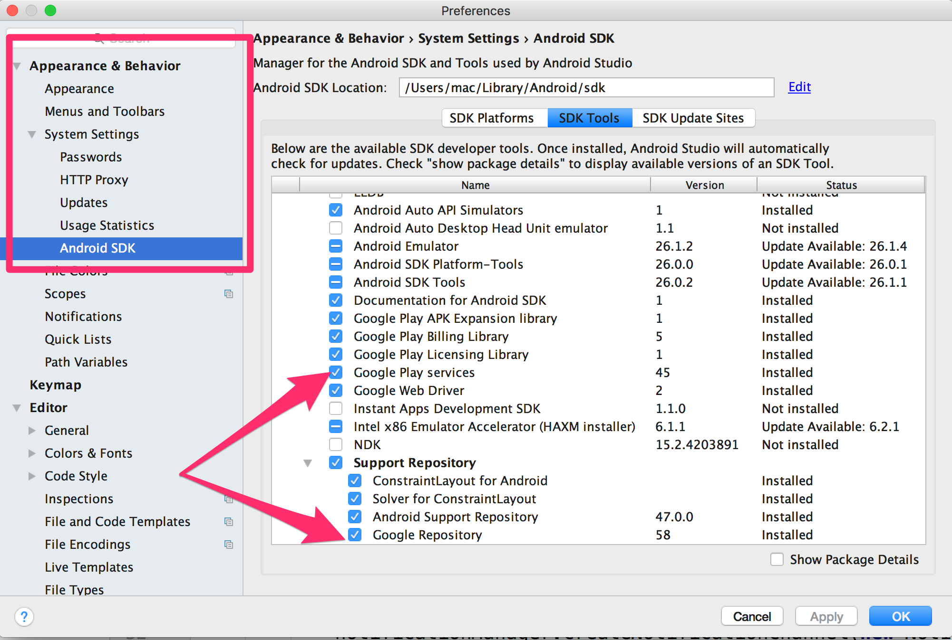

**#2 Create Android Project and get the Package ID**

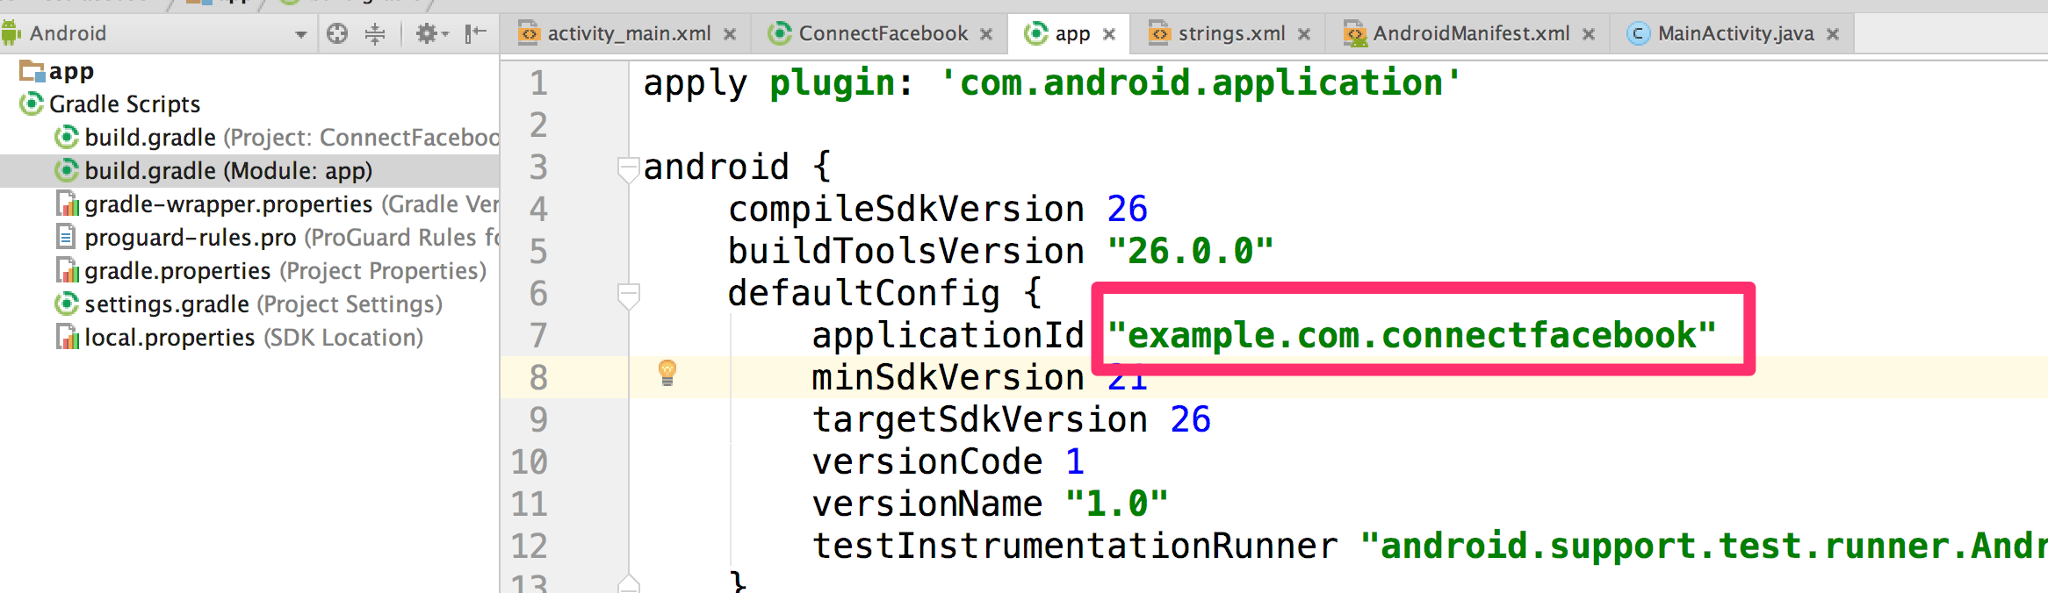

**#3 Generate Android Signing Certificate SHA-1**

Open console and run this command line:

keytool -list -v -keystore ~/.android/debug.keystore -alias androiddebugkey -storepass android -keypass android

On Window, Please use:

keytool -list -v -keystore "**%LOGGING_IN_USER_PROFILE_PATH%**\.android\debug.keystore" -alias androiddebugkey -storepass android -keypass android

Note: %LOGGING_IN_USER_PROFILE_PATH% = C:\Users\YOUR_WINDOW_USER_NAME

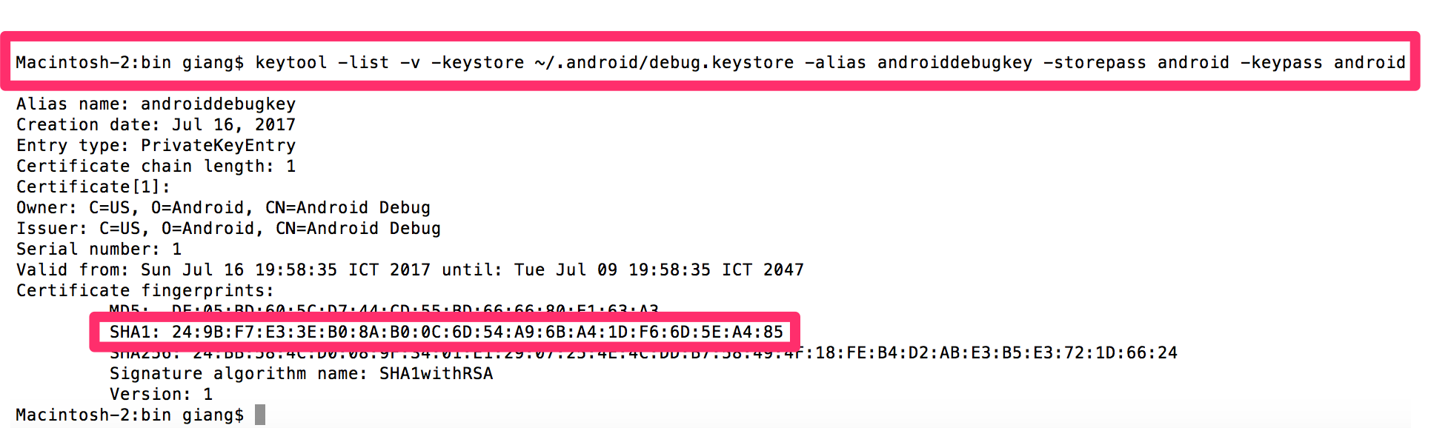

**#4 Use #2 to: create Google Firebase Project and get/download the Configuration file (**google-services.json**)**

[**https://developers.google.com/mobile/add?platform=android&cntapi=signin&cnturl=https:%2F%2Fdevelopers.google.com%2Fidentity%2Fsign-in%2Fandroid%2Fsign-in%3Fconfigured%3Dtrue&cntlbl=Continue%20Adding%20Sign-In**](https://developers.google.com/mobile/add?platform=android&cntapi=signin&cnturl=https:%2F%2Fdevelopers.google.com%2Fidentity%2Fsign-in%2Fandroid%2Fsign-in%3Fconfigured%3Dtrue&cntlbl=Continue%20Adding%20Sign-In)

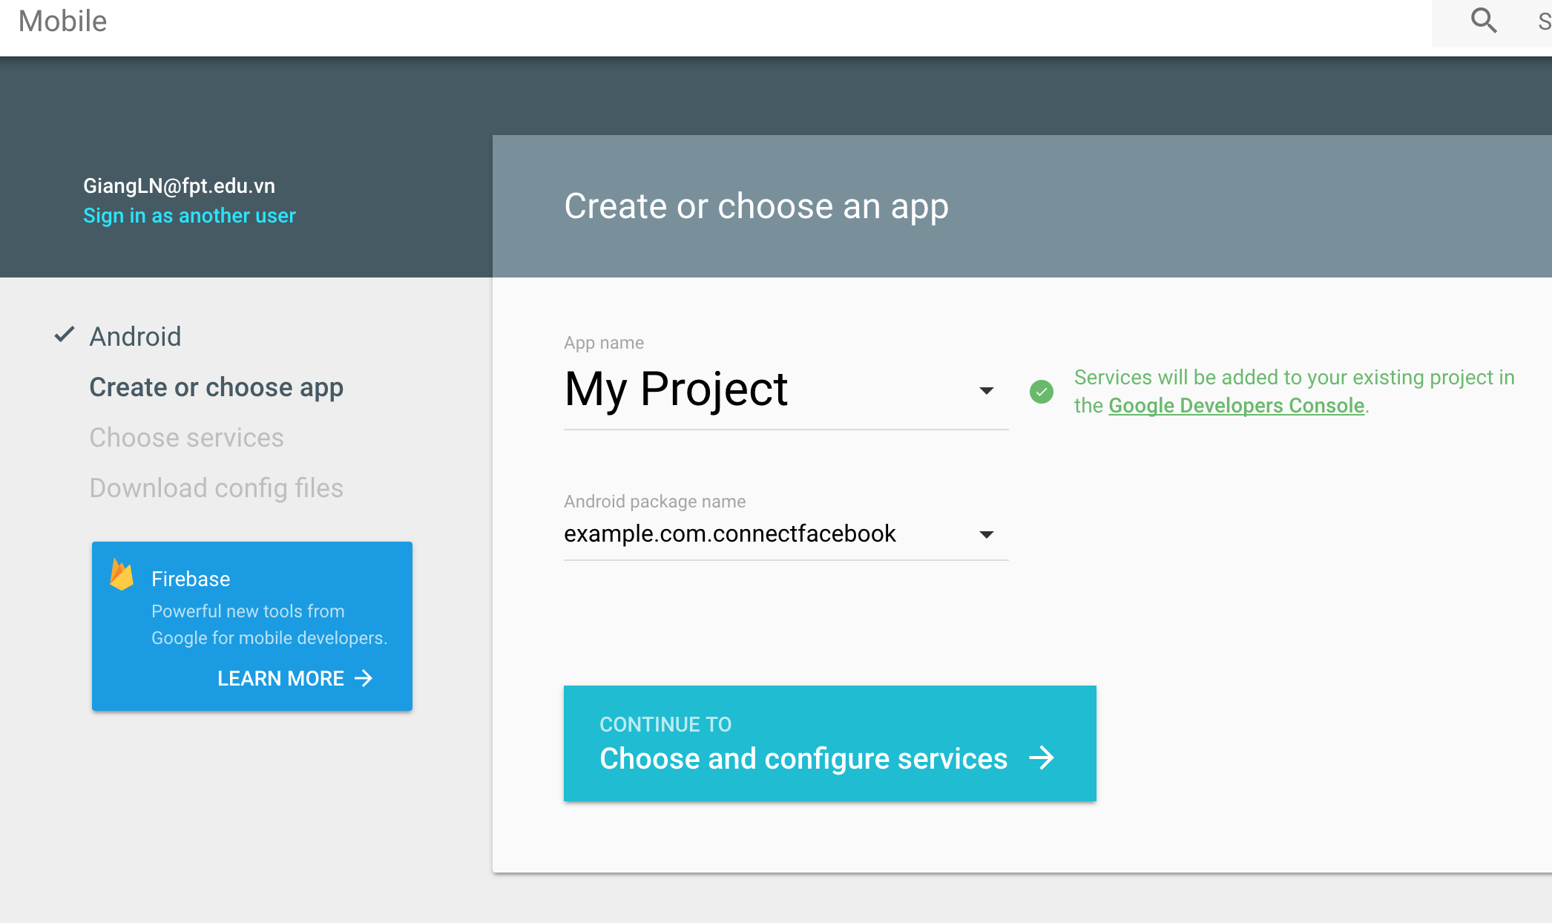

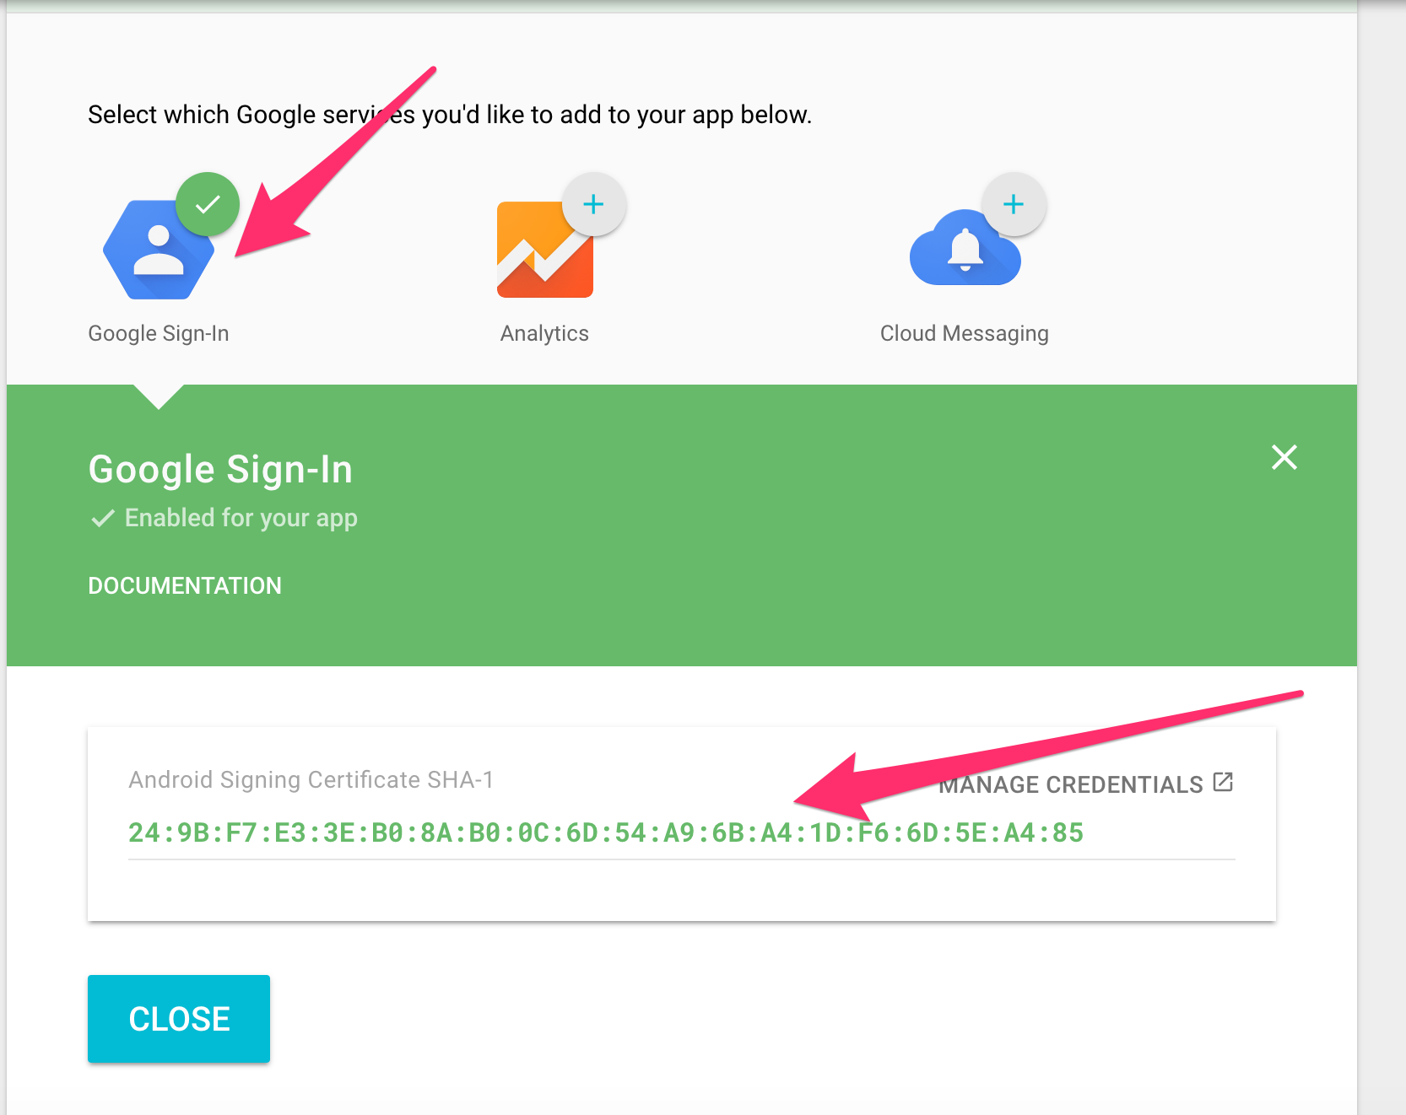

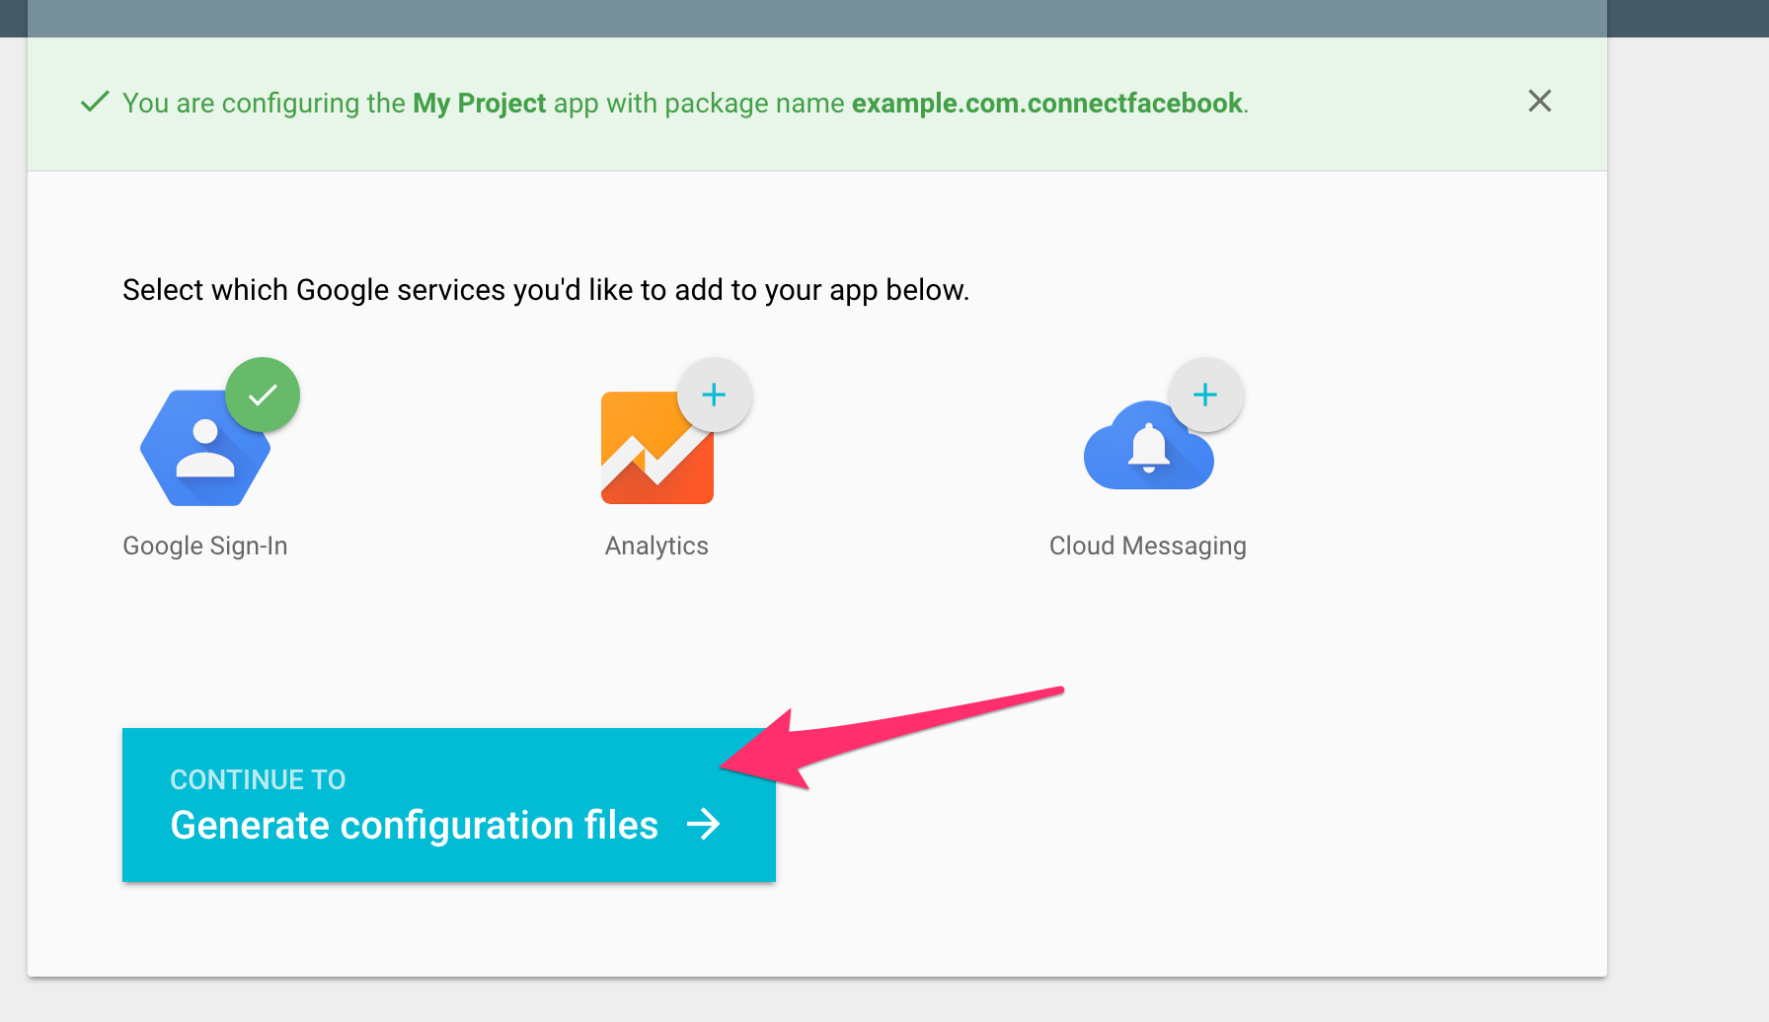

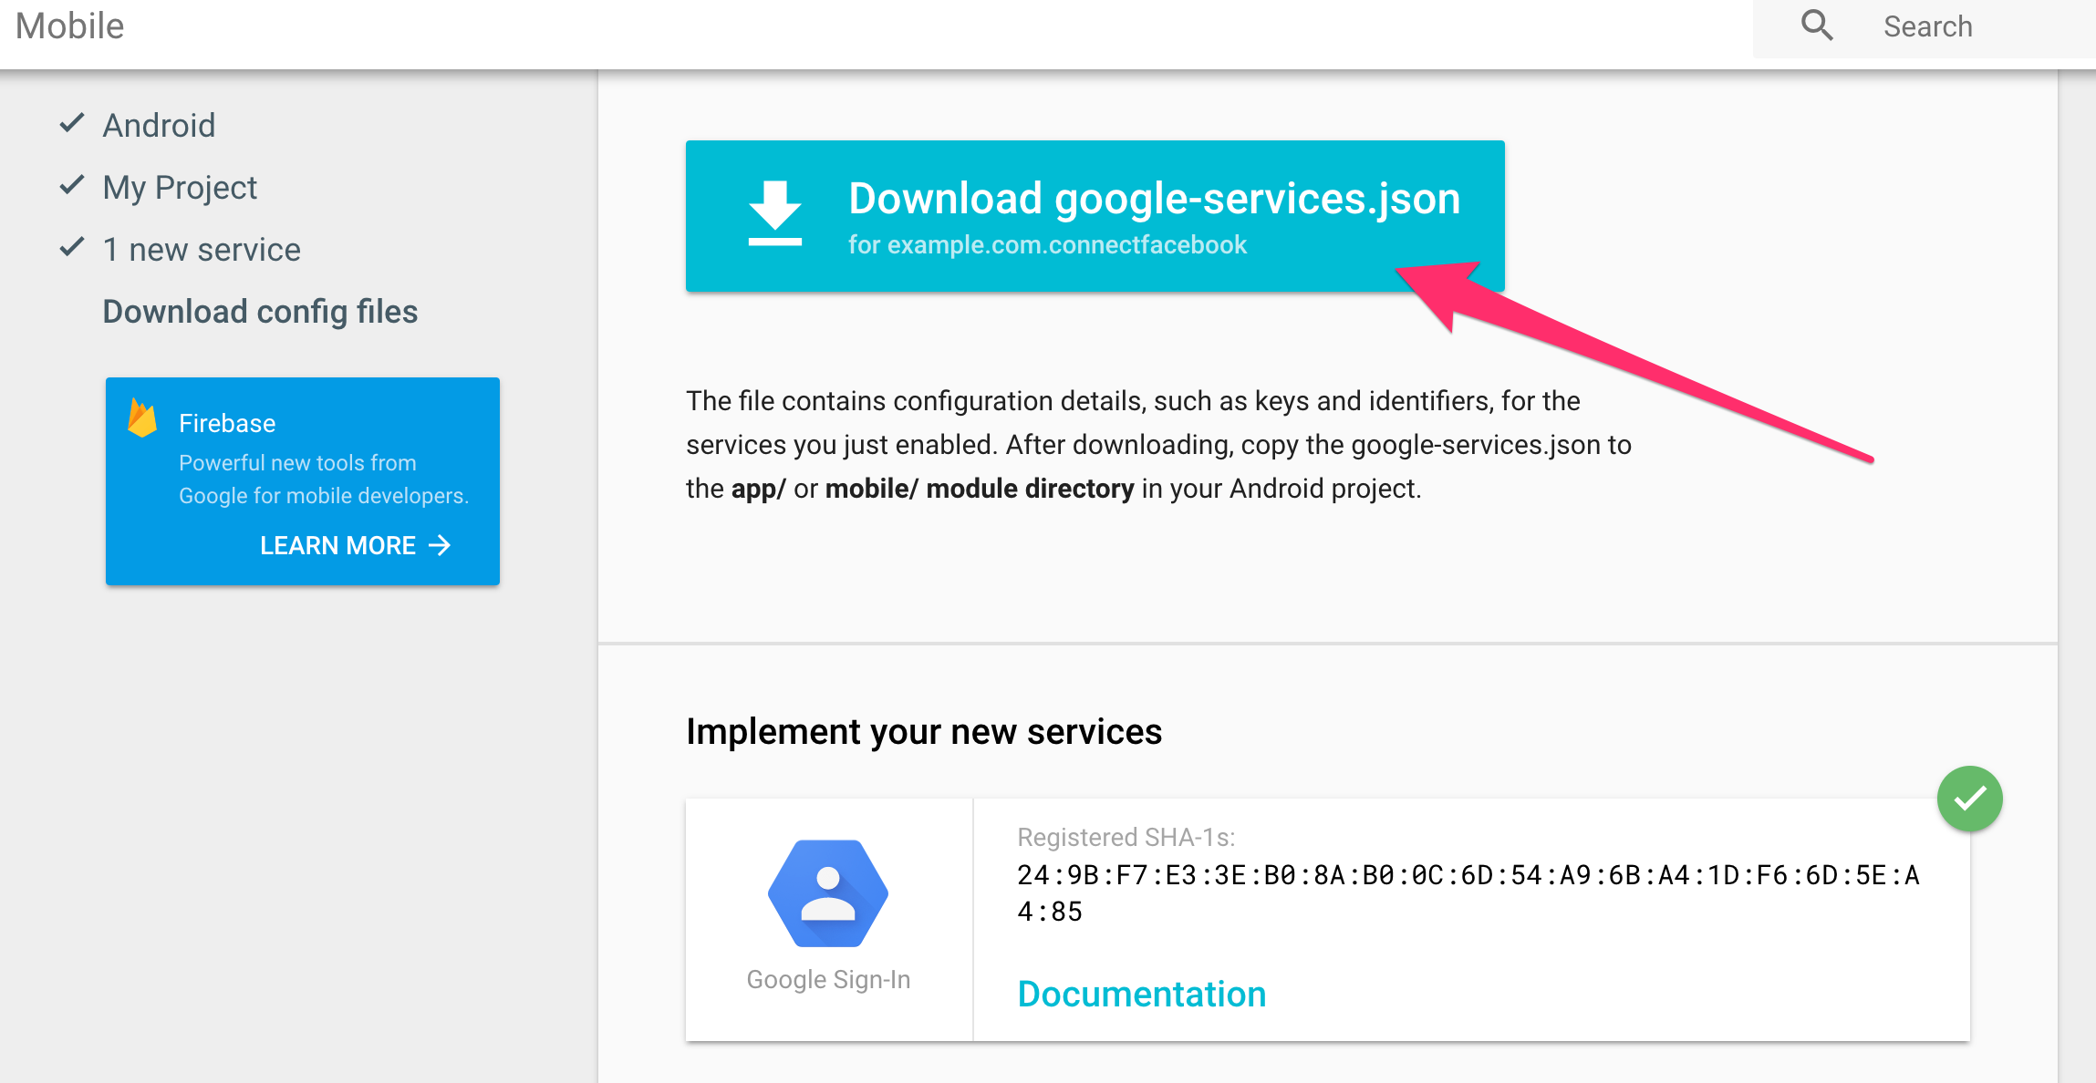

**#5 Put The** google-services.json **into your project:**

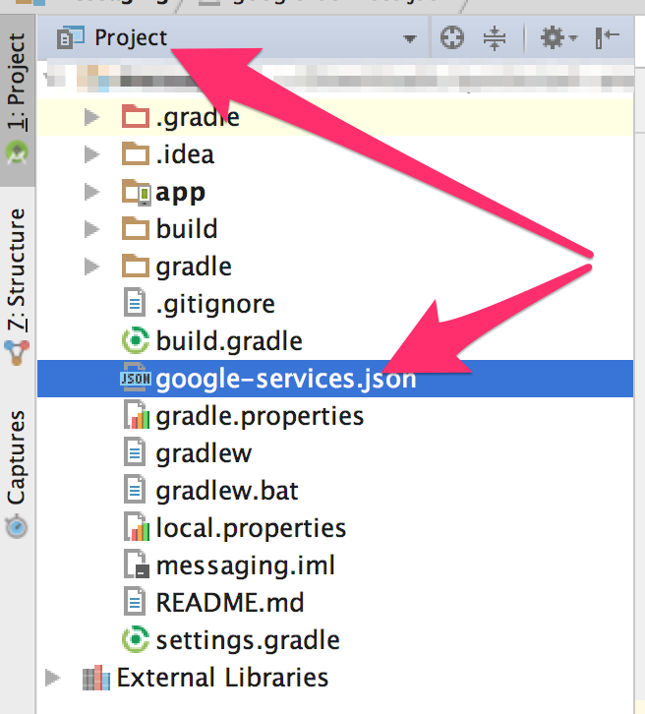

**#6 Add Google Signin library:**

**classpath 'com.google.gms:google-services:3.0.0'**

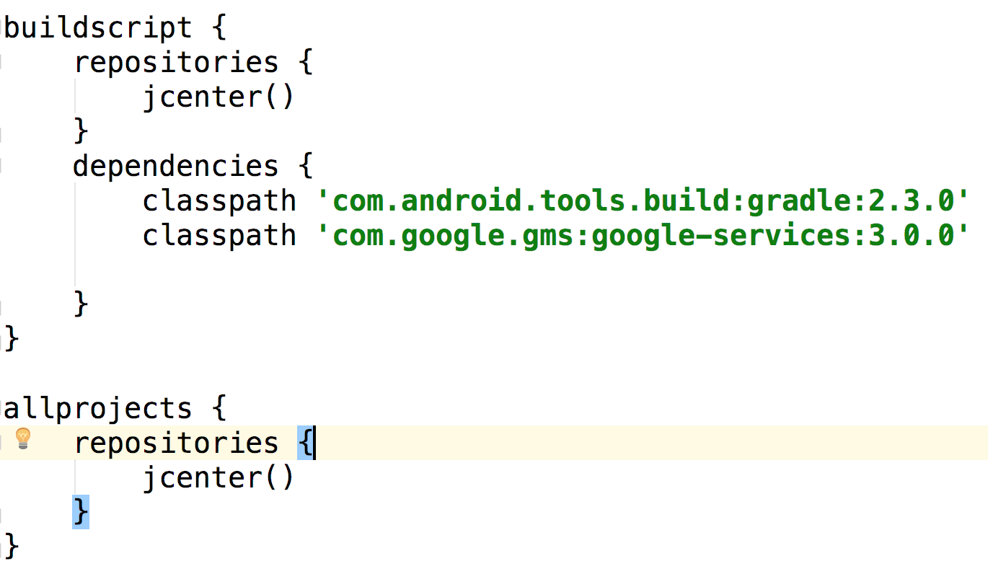

**compile 'com.google.android.gms:play-services-auth:9.0.0'**

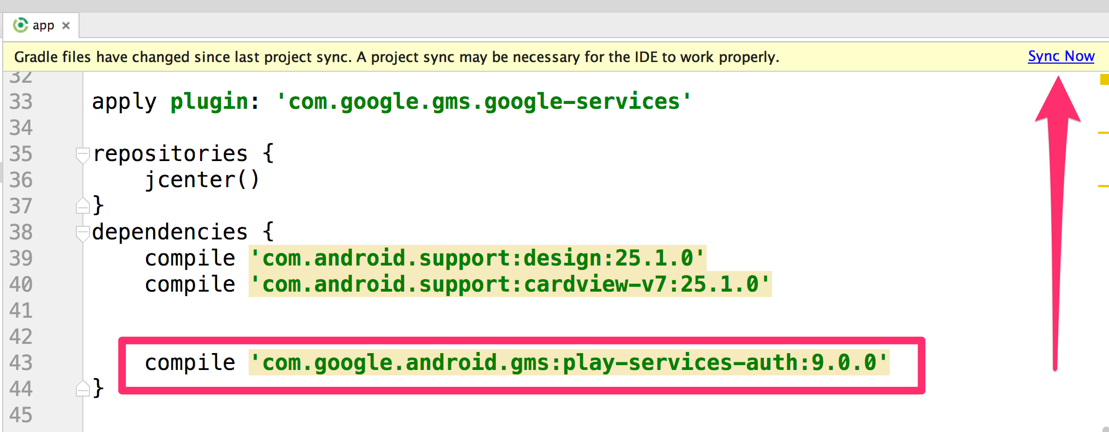

**#7 Add the Google button inside the layout.xml file:**

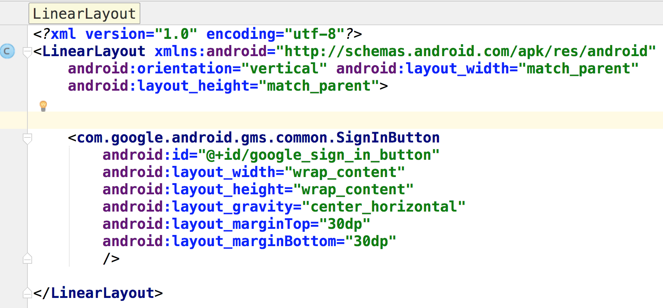

**#8 MainActivity.java Init the Google Tracker:**

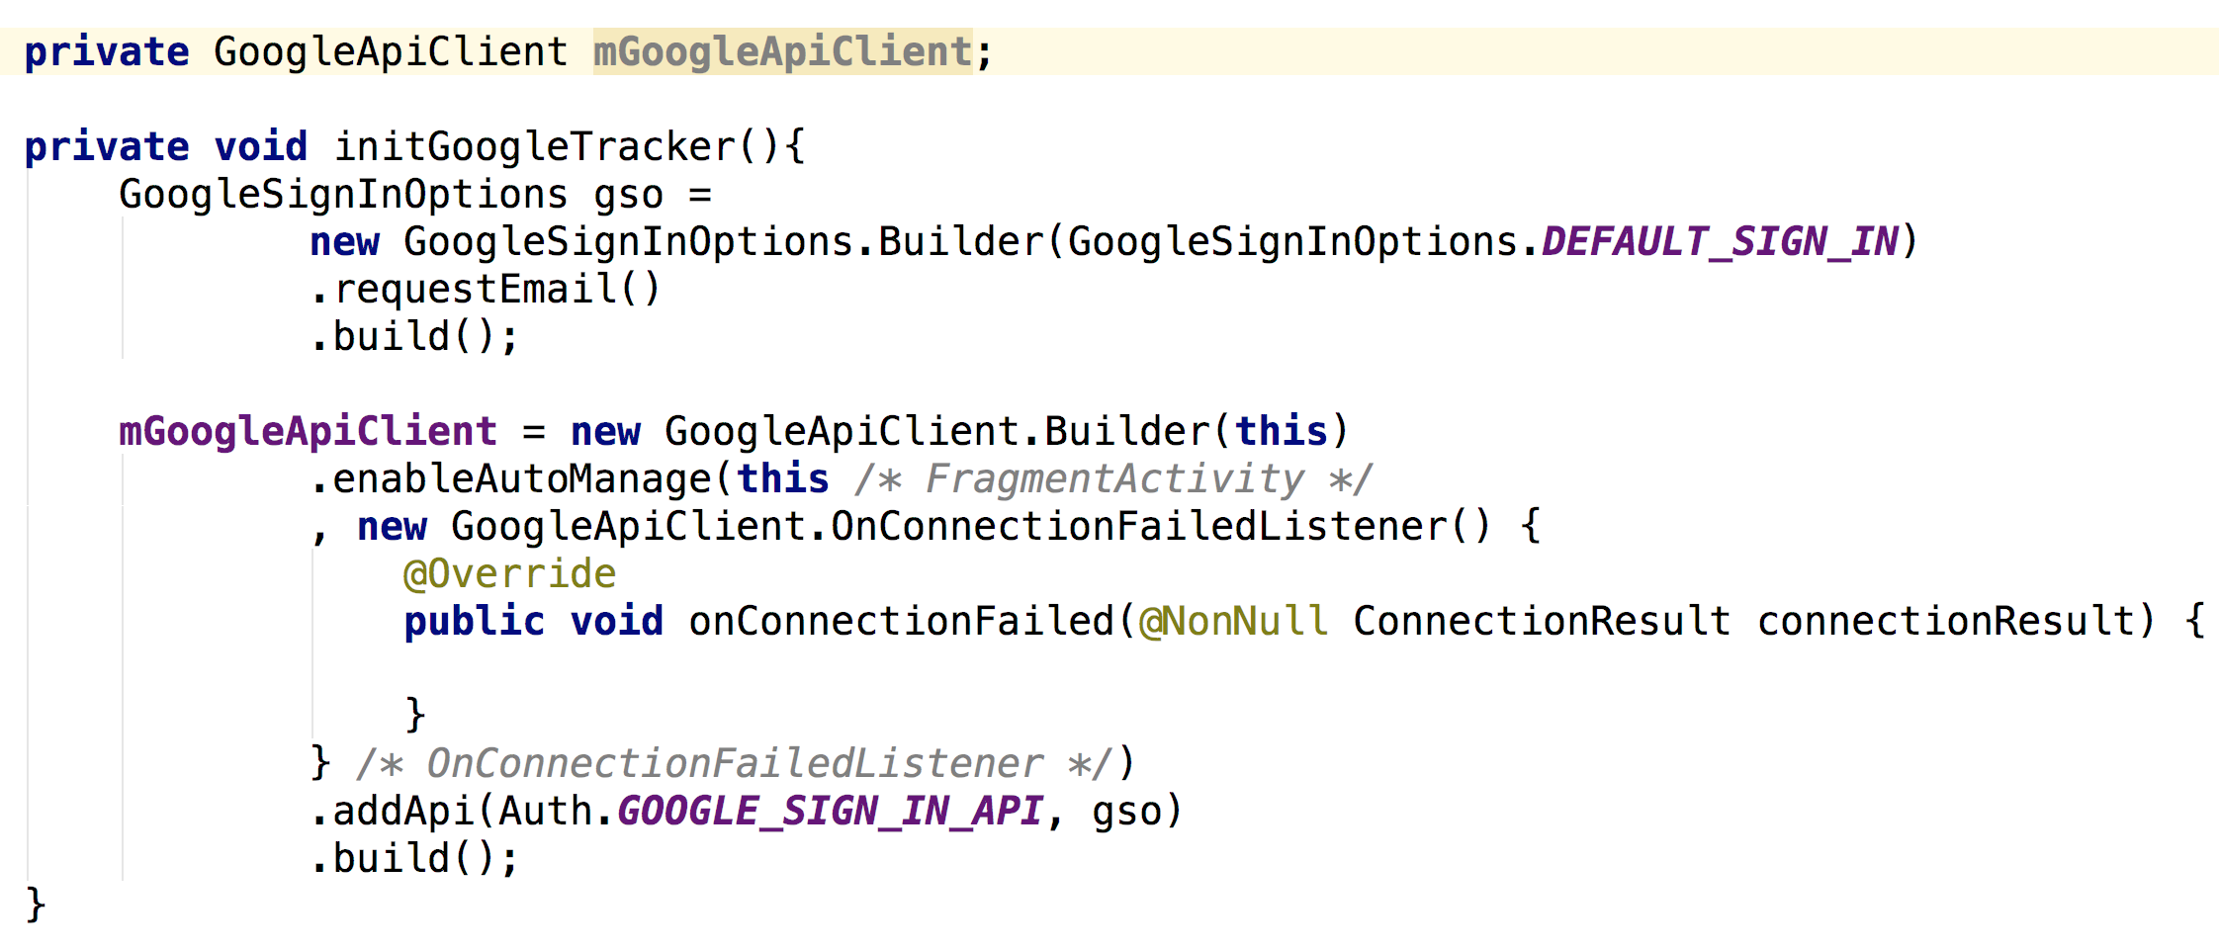

Please make sure that you call the method initGoogleTracker() first before load the layout.xml, as below:

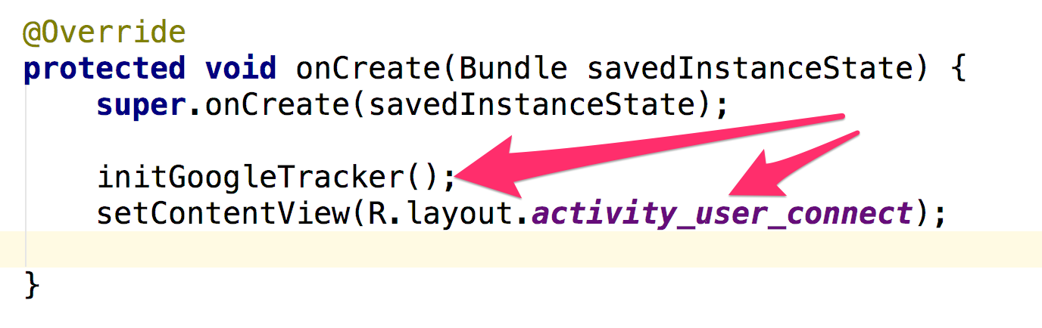

**#9 Load the button from XML into Java:**

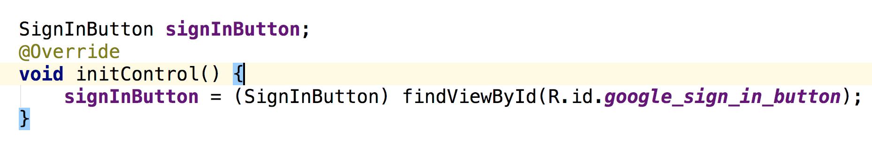

**#10 Adjust the button size:**

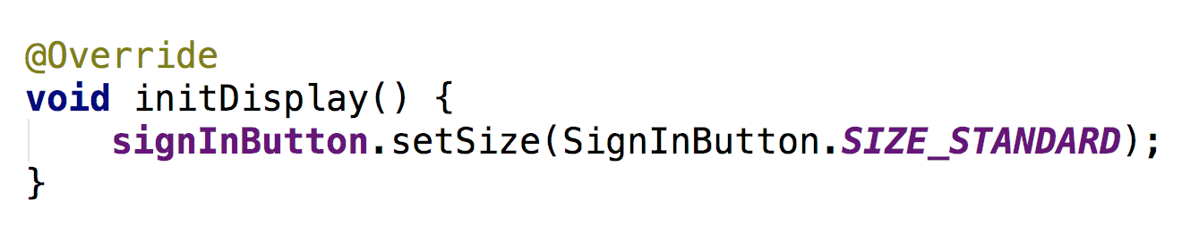

**#11 Prepare the action for Button Click Event:**

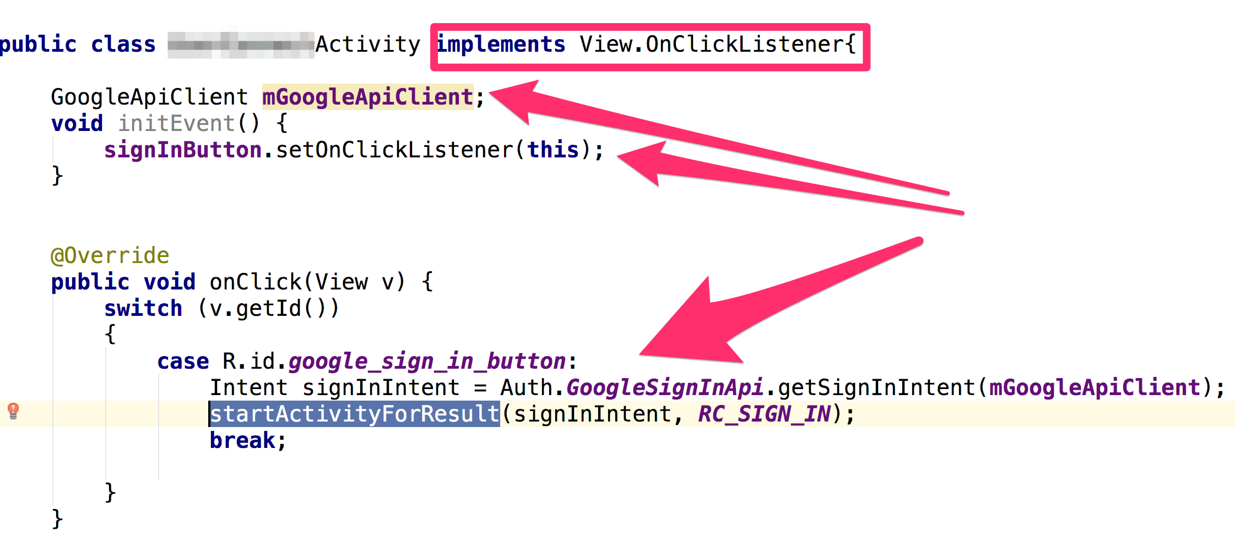



**#12 Handle the app behavior after user come back from Google Activity:**

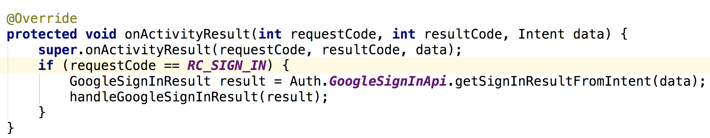

**#13 Data Response Handling:**

